erDiagram

DOCTOR ||--o{ DOCTOR_SLOT : has
DOCTOR_SLOT ||--o{ TOKEN : contains
PATIENT ||--o{ TOKEN : receives
BOOKING_SOURCE ||--o{ TOKEN : generates
TOKEN ||--o{ TOKEN_EVENT_AUDIT : logs
PATIENT ||--o{ NOTIFICATION : receives
DOCTOR_SLOT ||--o{ NOTIFICATION : triggers

DOCTOR {
UUID doctor_id PK
string name
string specialization
enum status
timestamp created_at
timestamp updated_at
}

DOCTOR_SLOT {
UUID slot_id PK
UUID doctor_id FK
date slot_date
time start_time
time end_time
int max_capacity
int current_capacity
enum slot_status
int delay_minutes
timestamp created_at
}

PATIENT {
UUID patient_id PK
string name
string mobile_number
timestamp created_at
}

BOOKING_SOURCE {
int source_id PK
string source_name
int priority_level
}

TOKEN {
UUID token_id PK
UUID slot_id FK
UUID patient_id FK
int source_id FK
int priority_level
int token_number
enum status
boolean is_priority_override
timestamp created_at
timestamp updated_at
}

TOKEN_EVENT_AUDIT {
UUID event_id PK
UUID token_id FK
enum event_type
int old_token_number
int new_token_number
string reason
timestamp event_time
}

NOTIFICATION {
UUID notification_id PK
UUID patient_id FK
UUID slot_id FK
string message
enum instruction
enum status
timestamp created_at
}

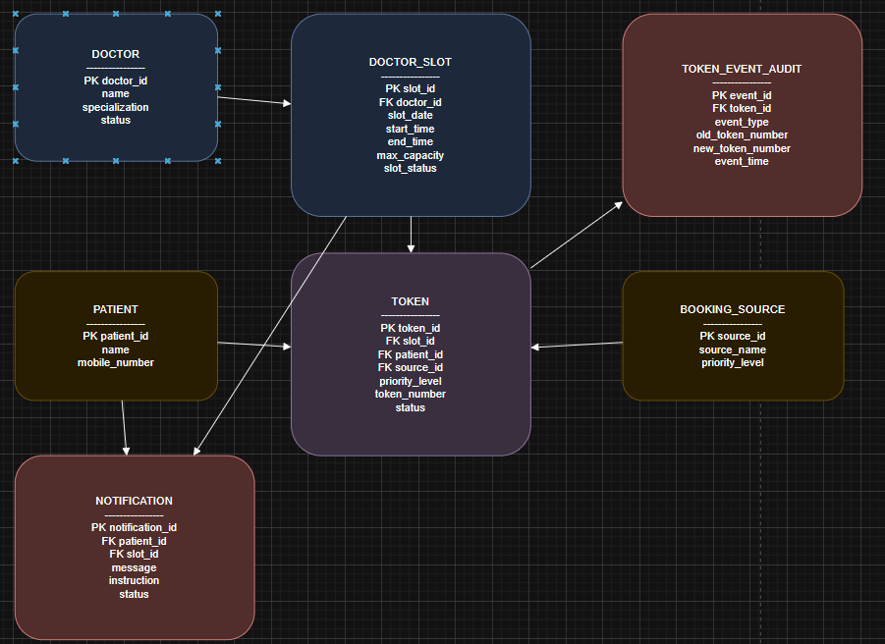

Create table data
-- =========================
-- DOCTOR TABLE
-- =========================
CREATE TABLE doctor (
doctor_id CHAR(36) PRIMARY KEY,
name VARCHAR(100) NOT NULL,
specialization VARCHAR(100),
status ENUM('PRESENT','ABSENT','DELAYED') DEFAULT 'PRESENT',
created_at TIMESTAMP DEFAULT CURRENT_TIMESTAMP,
updated_at TIMESTAMP DEFAULT CURRENT_TIMESTAMP ON UPDATE CURRENT_TIMESTAMP
);

-- =========================
-- PATIENT TABLE
-- =========================
CREATE TABLE patient (
patient_id CHAR(36) PRIMARY KEY,
name VARCHAR(100) NOT NULL,
mobile_number VARCHAR(15),
created_at TIMESTAMP DEFAULT CURRENT_TIMESTAMP
);

-- =========================
-- BOOKING SOURCE TABLE
-- =========================
CREATE TABLE booking_source (
source_id INT PRIMARY KEY,
source_name VARCHAR(50) UNIQUE,
priority_level INT NOT NULL
);

-- =========================
-- DOCTOR SLOT TABLE
-- =========================
CREATE TABLE doctor_slot (
slot_id CHAR(36) PRIMARY KEY,
doctor_id CHAR(36),
slot_date DATE,
start_time TIME,
end_time TIME,
max_capacity INT,
current_capacity INT DEFAULT 0,
slot_status ENUM('ACTIVE','DELAYED','CANCELLED','CLOSED') DEFAULT 'ACTIVE',
delay_minutes INT DEFAULT 0,
created_at TIMESTAMP DEFAULT CURRENT_TIMESTAMP,
FOREIGN KEY (doctor_id) REFERENCES doctor(doctor_id)
);

-- =========================
-- TOKEN TABLE
-- =========================
CREATE TABLE token (
token_id CHAR(36) PRIMARY KEY,
slot_id CHAR(36),
patient_id CHAR(36),
source_id INT,
priority_level INT,
token_number INT,
status ENUM('ACTIVE','CANCELLED','COMPLETED') DEFAULT 'ACTIVE',
is_priority_override BOOLEAN DEFAULT FALSE,
created_at TIMESTAMP DEFAULT CURRENT_TIMESTAMP,
updated_at TIMESTAMP DEFAULT CURRENT_TIMESTAMP ON UPDATE CURRENT_TIMESTAMP,
FOREIGN KEY (slot_id) REFERENCES doctor_slot(slot_id),
FOREIGN KEY (patient_id) REFERENCES patient(patient_id),
FOREIGN KEY (source_id) REFERENCES booking_source(source_id)
);

-- =========================
-- TOKEN EVENT AUDIT TABLE
-- =========================
CREATE TABLE token_event_audit (
event_id CHAR(36) PRIMARY KEY,
token_id CHAR(36),
event_type ENUM('PRIORITY_CHANGE','CANCELLED','REALLOCATED'),
old_token_number INT,
new_token_number INT,
reason TEXT,
event_time TIMESTAMP DEFAULT CURRENT_TIMESTAMP,
FOREIGN KEY (token_id) REFERENCES token(token_id)
);

-- =========================
-- NOTIFICATION TABLE
-- =========================
CREATE TABLE notification (
notification_id CHAR(36) PRIMARY KEY,
patient_id CHAR(36),
slot_id CHAR(36),
message TEXT,
instruction ENUM('WAIT','HOLD','RESCHEDULE','NO_ACTION'),
status ENUM('SENT','FAILED','PENDING') DEFAULT 'PENDING',
created_at TIMESTAMP DEFAULT CURRENT_TIMESTAMP,
FOREIGN KEY (patient_id) REFERENCES patient(patient_id),
FOREIGN KEY (slot_id) REFERENCES doctor_slot(slot_id)
);

2. INSERT MASTER DATA
-- ========================= -- DOCTORS -- =========================
INSERT INTO doctor
VALUES ('D1','Dr Amit Sharma','Cardiology','PRESENT',NOW(),NOW()), ('D2','Dr Neha Verma','Orthopedics','PRESENT',NOW(),NOW()), ('D3','Dr Ravi Singh','General Medicine','PRESENT',NOW(),NOW()); -- ========================= -- PATIENTS -- =========================
INSERT INTO patient
VALUES ('P1','Rahul Kumar','9876543210',NOW()), ('P2','Anita Mehta','9876501234',NOW()), ('P3','Suresh Patel','9988776655',NOW()), ('P4','Priya Sharma','9123456789',NOW()); -- ========================= -- BOOKING SOURCES -- =========================
INSERT INTO booking_source
VALUES (1,'EMERGENCY',1), (2,'FOLLOW_UP',2), (3,'PAID',3), (4,'ONLINE',4), (5,'WALK_IN',5);

3. INSERT SLOTS
-- ========================= -- DOCTOR SLOTS -- =========================
INSERT INTO doctor_slot
VALUES ('S1','D1','2026-02-01','09:00:00','10:00:00',5,0,'ACTIVE',0,NOW()), ('S2','D1','2026-02-01','10:00:00','11:00:00',5,0,'ACTIVE',0,NOW()), ('S3','D2','2026-02-01','10:00:00','11:00:00',4,0,'ACTIVE',0,NOW());

4. INSERT TOKENS (QUEUE CREATION)
-- ========================= -- TOKENS -- =========================
INSERT INTO token VALUES ('T1','S1','P1',1,1,1,'ACTIVE',TRUE,NOW(),NOW()), ('T2','S1','P2',2,2,2,'ACTIVE',FALSE,NOW(),NOW()), ('T3','S1','P3',3,3,3,'ACTIVE',FALSE,NOW(),NOW()), ('T4','S1','P4',4,4,4,'ACTIVE',FALSE,NOW(),NOW());

5. TOKEN REALLOCATION EVENT (EXAMPLE)
-- ========================= -- TOKEN EVENT AUDIT -- =========================
INSERT INTO token_event_audit VALUES ('E1','T3','REALLOCATED',3,4,'Emergency patient inserted',NOW());

6. NOTIFICATION EXAMPLE
-- ========================= -- NOTIFICATIONS -- =========================
INSERT INTO notification VALUES ('N1','P3','S1', 'Your token number has changed due to an emergency case.', 'WAIT', 'SENT', NOW());

7. IMPORTANT QUERIES (INTERVIEW READY)
-- Get live queue for a slot SELECT token_number, patient_id, priority_level FROM token WHERE slot_id = 'S1' AND status = 'ACTIVE' ORDER BY priority_level, token_number;
-- Check remaining capacity SELECT max_capacity - current_capacity AS remaining FROM doctor_slot WHERE slot_id = 'S1';

